VoIP Intrusion Detection Dataset — Generation Documentation
Lab Environment
Component | Details
Asterisk PBX Server | Ubuntu VM — 10.223.247.162
Kali Linux (Attacker) | Bridged VM — same hotspot network
Client 1 | Mobile with Zoiper — same network
Client 2 | Mobile with Zoiper — same network
Network | Mobile hotspot — all devices bridged
Capture Duration | ~15 minutes per attack
Packets per Capture | 90,000+ packets

Asterisk PBX Setup
Install Asterisk on Ubuntu VM
bash
sudo apt update && sudo apt upgrade -y
sudo apt install asterisk -y
sudo systemctl start asterisk
sudo systemctl enable asterisk
SIP Extension Configuration
File: /etc/asterisk/sip.conf

[general]
context=default
allowguest=no
qualify=yes
language=en

[1001]
type=friend
host=dynamic
secret=password123
context=phones
callerid=Client1 <1001>
allow=ulaw
allow=alaw

[1002]
type=friend
host=dynamic
secret=password123
context=phones
callerid=Client2 <1002>
allow=ulaw
allow=alaw
Dialplan Configuration
File: /etc/asterisk/extensions.conf
ini
[phones]
exten => 1000,1,Dial(SIP/1000,20)
exten => 1000,2,Hangup()
exten => 1001,1,Dial(SIP/1001,20)
exten => 1001,2,Hangup()
Reload Asterisk After Config Changes
bash
sudo asterisk -rx "sip reload"
sudo asterisk -rx "dialplan reload"
sudo asterisk -rx "sip show peers" ; verify clients 1 and 2 are registered
Verify Zoiper Clients Are Connected
bash
sudo asterisk -rx "sip show peers"
Expected output should show 1000 and 1001 as OK with their mobile IPs.

Attack 1 — nmap (SIP Reconnaissance & Port Scanning)
Attack Type
Active network reconnaissance and SIP service discovery
Objective
Simulate an attacker scanning the network to discover open ports, identify the PBX server, and fingerprint the SIP service.
TCPDump Capture Command (on Asterisk Ubuntu VM)
bash
sudo tcpdump -i any -w nmap_scan.pcap not port 0 and not \(src port 0 or dst port 0\)
Attack Commands (on Kali VM)
bash
# Basic SIP UDP port scan
nmap -sU -p 5060 10.223.247.162

# Service version detection with SIP script
nmap -sV -sU -p 5060 --script=sip-methods 10.223.247.162

# Aggressive scan with OS detection and SIP enumeration
nmap -A -sU -sS -p 5060,5061,4569,2727 --script sip-methods,sip-enum-users 10.223.247.162

# Full TCP port sweep for broad reconnaissance
nmap -sS -p 1-65535 10.223.247.162
What Was Generated
- TCP SYN flood across all 65535 ports
- UDP probes targeting SIP ports 5060, 5061, 4569
- SIP OPTIONS and REGISTER messages from NSE scripts
- OS fingerprinting probes (malformed/out-of-state TCP packets)
Anomaly Signatures
- Port sweep from single source IP
- Out-of-state TCP packets with no prior session
- SIP OPTIONS from unregistered User-Agent
- Rapid sequential probes with no legitimate call flow

Capture Stats
Metric | Value
Duration | ~15 minutes
Packet Count | 90,000+
Output File | nmap_scan.pcap
Protocol Mix | TCP, UDP, SIP

CICFlowmeter Output:
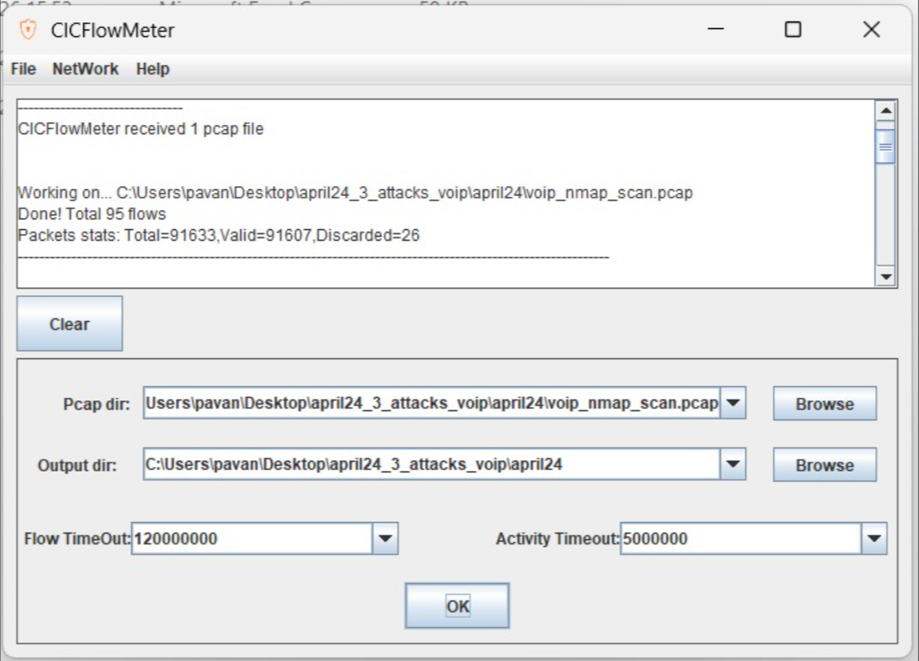

Attack 2 — svmap (SIP Device Scanner)
Attack Type
SIP-layer reconnaissance and device fingerprinting
Objective
Simulate an attacker discovering all SIP-capable devices on the network including the PBX server and registered Zoiper clients.
TCPDump Capture Command (on Asterisk Ubuntu VM)
bash
sudo tcpdump -i any -w svmap_scan.pcap not port 0 and not \(src port 0 or dst port 0\)
Attack Commands (on Kali VM)
bash
# Basic scan targeting Asterisk server
svmap 10.223.247.162

# Scan with explicit SIP port
svmap 10.223.247.162 -p 5060

# Subnet scan — hits server and both Zoiper phones
svmap 10.223.247.0/24

# Aggressive threaded OPTIONS scan
svmap 10.223.247.162 -p 5060 --method=OPTIONS -t 10

# REGISTER method scan for different response fingerprinting
svmap 10.223.247.162 -p 5060 --method=REGISTER
What Was Generated
- High volume SIP OPTIONS requests to server and subnet
- SIP REGISTER attempts from unregistered UA
- Asterisk responded with 200 OK to OPTIONS and 401 to REGISTER
- Zoiper phones also received probe packets during subnet scan
Anomaly Signatures
- Rapid sequential SIP OPTIONS from single attacker IP
- SIP scanning pattern across /24 subnet
- REGISTER attempts with no prior authentication context
- High SIP message rate with no legitimate call flow
Capture Stats
Metric | Value
Duration | ~15 minutes
Packet Count | 90,000+
Output File | svmap_scan.pcap
Protocol Mix | UDP, SIP
CICFlowmeter Output:
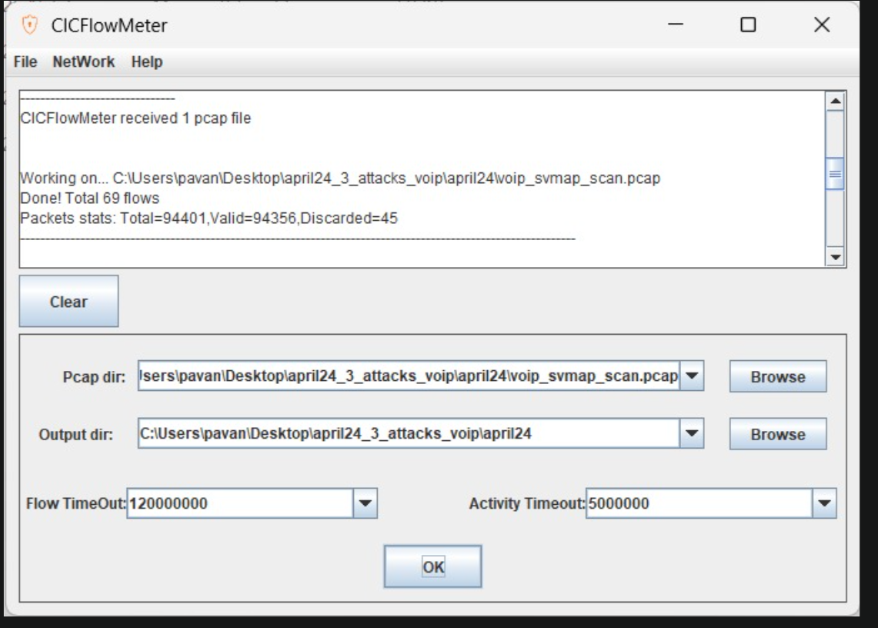

Attack 3 — svwar (SIP Extension Enumerator)
Attack Type
SIP user enumeration / brute-force extension discovery
Objective
Simulate an attacker attempting to discover valid SIP extensions (user accounts) registered on the Asterisk PBX by probing hundreds of extension numbers.
TCPDump Capture Command (on Asterisk Ubuntu VM)
bash
sudo tcpdump -i any -w svwar_scan.pcap not port 0 and not \(src port 0 or dst port 0\)
Attack Commands (on Kali VM)
bash
# Basic enumeration range 100-999
svwar -e100-999 10.223.247.162

# Using INVITE method
svwar -e100-999 10.223.247.162 -m INVITE

# Extended range 1000-9999
svwar -e1000-9999 10.223.247.162

# With explicit port and threading
svwar -e100-999 10.223.247.162 -p 5060 -t 10 --force

# OPTIONS method to bypass auth requirement
svwar -e100-999 10.223.247.162 -m OPTIONS --force

# Large range for maximum packet volume
svwar -e100-9999 10.223.247.162 -m OPTIONS
What Was Generated
- Hundreds of REGISTER/INVITE/OPTIONS requests per extension
- Asterisk responded with 401 Unauthorized + MD5 digest challenge for each
- Repeated challenge-response cycles across entire extension range
- No successful authentications — pure enumeration traffic pattern
Observed Behavior
Asterisk returned 401 Unauthorized with digest authentication challenge for every extension attempt. This is expected — the 401 flood itself is a valid and labelable anomaly pattern in the dataset.
Anomaly Signatures
- Sequential REGISTER/INVITE attempts across hundreds of extensions
- Repeated 401 Unauthorized responses from PBX in rapid succession
- Single source IP generating abnormally high SIP request rate
- No successful call setup — no ACK, BYE, or RTP traffic following requests
Capture Stats
Metric | Value
Duration | ~15 minutes
Packet Count | 90,000+
Output File | svwar_scan.pcap
Protocol Mix | UDP, SIP
CICFlowmeter Output:
